1.router

2.switch

3.pc

4.router physical line set and wire(serial DTE) connect

5.connet switch and pc by copper straight through wire

6.router ar port number deoya like 11.0.0.1

7.router to switch ar ip deoya like 192.168.1.1(gateway)

8.pc ip deoya like 192.168.1.2 (ethernet)

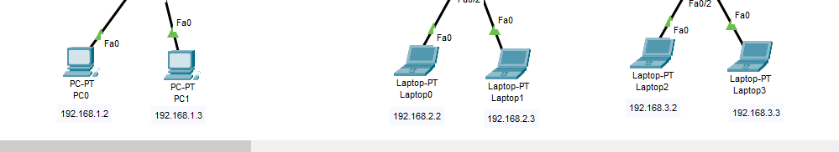

9.pc Ip configuration

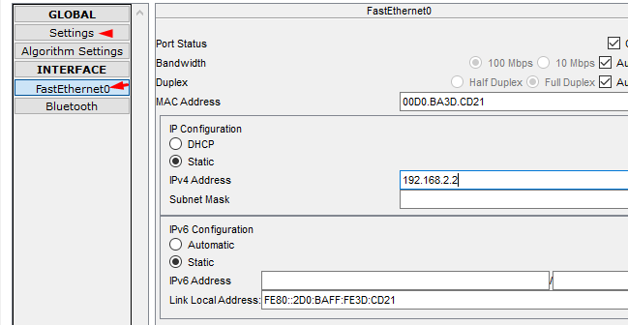

10.router to router connection

